 Ideation Phase
BrainStrom & Idea Prioritization Template

Date | 27 January 2026
Team ID | LTVIP2026TMIDS28465
Project Name | ShopEZ: One-Stop Shop for Online  Purchases
Maximum Marks | 4 Marks

Brainstorm & Idea Prioritization
Reference: https://www.mural.co/templates/brainstorm-and-idea-prioritization
Step 1: Team Gathering, Collaboration & Selecting the Problem Statement
Brainstorming is the launchpad for innovation in the ShopEZ project. It creates a free and open environment where every team member can contribute ideas—no matter how unconventional. This step is all about collaborative creativity and problem discover.
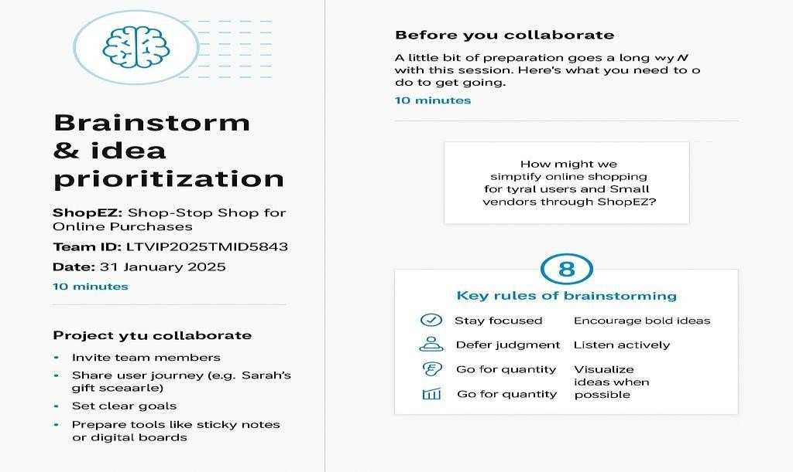


Step-2: Brainstorm, Idea Listing and Grouping
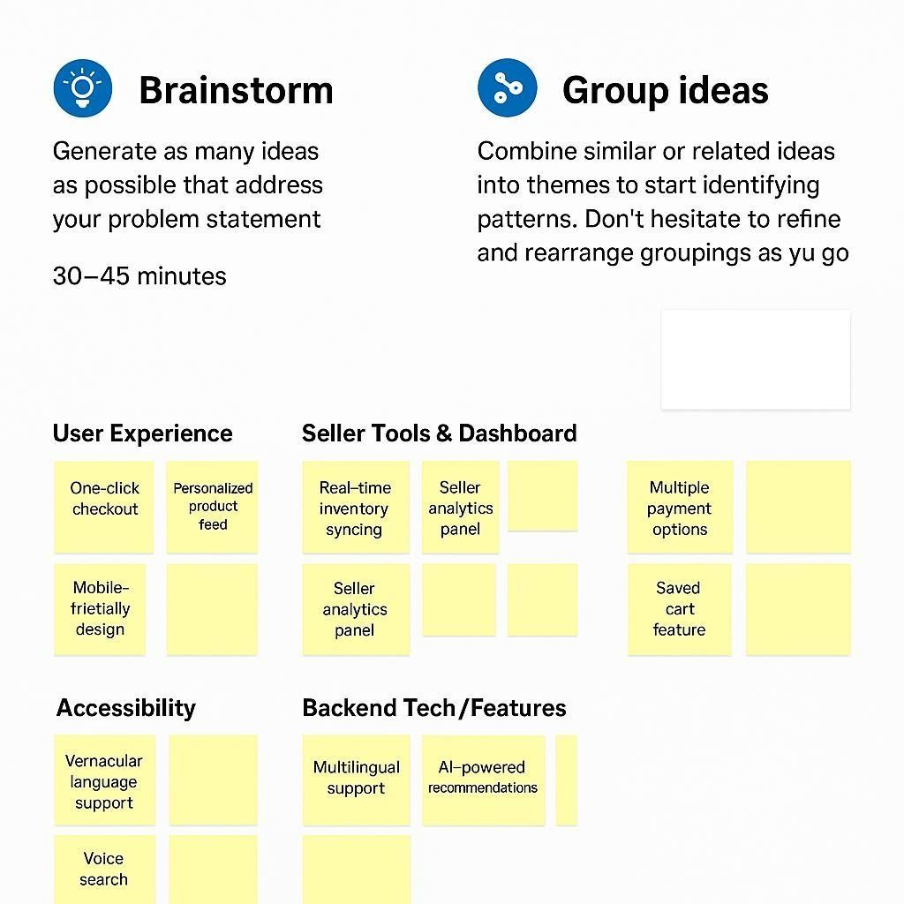
Step-3: Idea Prioritization
